Section D — AI-Augmented Learning

Cisco Packet Tracer — Router-on-a-Stick Practical
STEP 1 · BUILD WITH AI
AI Tool Used: ChatGPT
1. Exact Prompt Given to AI
I am doing a Cisco Packet Tracer practical. Generate a complete Cisco IOS configuration for a Router-on-a-Stick topology.

Requirements:
Configure VLAN 10 and VLAN 20 on the switch.
Assign switch ports to VLAN 10 and VLAN 20.
Configure an 802.1Q trunk between the switch and router.
Configure Router-on-a-Stick sub-interfaces on the router for VLAN 10 and VLAN 20.
Configure IP addresses/gateways so that a PC in VLAN 10 can communicate with a PC in VLAN 20.
Provide complete switch and router commands.
Explain how to configure the PCs.
The final configuration should allow successful ping between the VLAN 10 and VLAN 20 hosts.

2. AI Original Configuration Script Topology:
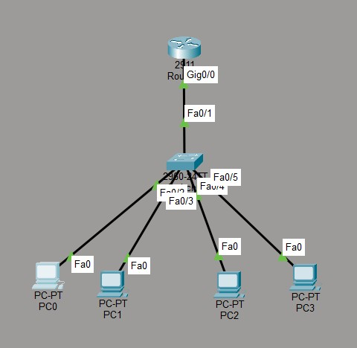
IP Address Plan:
Device | VLAN | IP Address | Subnet Mask | Gateway
PC0 | 10 | 192.168.10.10 | 255.255.255.0 | 192.168.10.1
PC1 | 20 | 192.168.20.10 | 255.255.255.0 | 192.168.20.1
Router Subinterface | 10 | 192.168.10.1 | 255.255.255.0 | —
Router Subinterface | 20 | 192.168.20.1 | 255.255.255.0 | —
Switch — AI Original:
enable configure terminal vlan 10 name VLAN10 exit vlan 20 name VLAN20 exit interface fastEthernet 0/1 switchport mode access switchport access vlan 10 no shutdown exit interface fastEthernet 0/2 switchport mode access switchport access vlan 20 no shutdown exit interface gigabitEthernet 0/1 switchport mode trunk no shutdown exit end write memory
Router — AI Original:
enable configure terminal interface gigabitEthernet 0/0 no shutdown exit
interface gigabitEthernet 0/0.10 encapsulation dot1Q 10 ip address 192.168.10.1 255.255.255.0 exit
interface gigabitEthernet 0/0.20 encapsulation dot1Q 20 ip address 192.168.20.1 255.255.255.0 exit end write memory
3. Testing in Packet Tracer PC0 Configuration:
IP Address: 192.168.10.10
Subnet Mask: 255.255.255.0 Default Gateway: 192.168.10.1
PC1 Configuration:
IP Address: 192.168.20.10
Subnet Mask: 255.255.255.0 Default Gateway: 192.168.20.1
Test command from PC0: ping 192.168.20.10

STEP 2 · TEST & DEBUG (WITHOUT AI)
Example bug found during testing: the trunk must carry both VLAN 10 and VLAN 20. If the trunk is restricted to only VLAN 10, VLAN 20 traffic cannot cross the switch-router trunk.
Corrected Switch Trunk Configuration:
interface gigabitEthernet 0/1 switchport mode trunk switchport trunk allowed vlan 10,20 no shutdown exit

Corrected Version — Complete Switch Configuration
enable
configure terminal
vlan 10 name VLAN10 exit vlan 20 name VLAN20 exit
interface fastEthernet 0/1 switchport mode access switchport access vlan 10 no shutdown exit
interface fastEthernet 0/2 switchport mode access switchport access vlan 20 no shutdown exit
interface gigabitEthernet 0/1 switchport mode trunk switchport trunk allowed vlan 10,20 no shutdown exit end write memory

Corrected Version — Router Configuration
enable
configure terminal

interface gigabitEthernet 0/0 no shutdown exit
interface gigabitEthernet 0/0.10 encapsulation dot1Q 10 ip address 192.168.10.1 255.255.255.0 exit
interface gigabitEthernet 0/0.20 encapsulation dot1Q 20 ip address 192.168.20.1 255.255.255.0 exit end write memory

3–4 Line Debugging Note
I tested the AI-generated configuration in Cisco Packet Tracer and found that the trunk needed to carry both VLAN 10 and VLAN 20. I corrected the trunk configuration by explicitly allowing VLANs 10 and 20. After making the correction, the Router-on-a-Stick configuration worked correctly and PC0 in VLAN 10 successfully pinged PC1 in VLAN 20. This was necessary because inter-VLAN traffic must be carried through the trunk for both VLANs.

